ASSIGNMENT 3

3.1.
3.1.1.
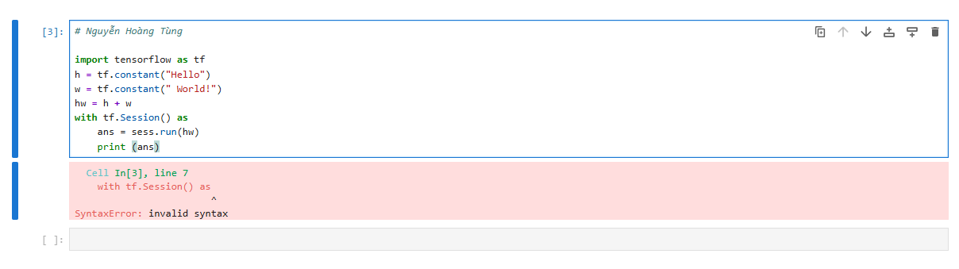
This code has an invalid syntax, should be fixed as the image below.
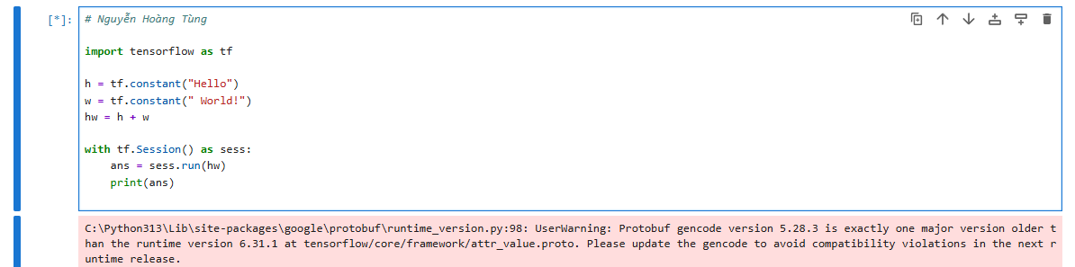
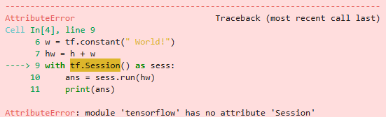
This code has been fixed but can only run on Tensorflow 1.4. To run on version 2.0 we need to change the code as follows, no need for Session, just .numpy() to get the value.
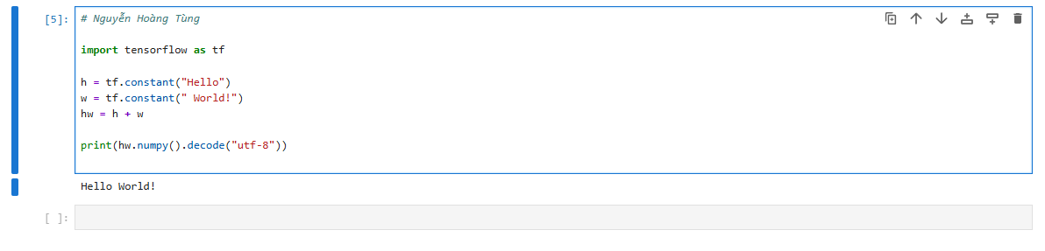
3.1.2.
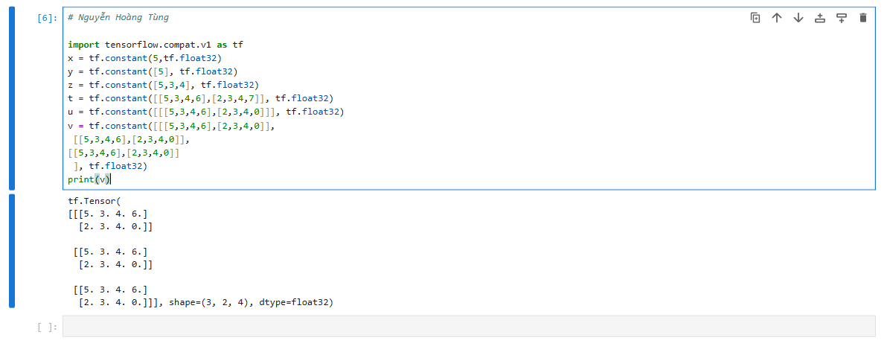
tf.constant() is used to create an tensor object (cannot be changed during execution), has a fixed value and is not updated when training the model.
tf.constant() helps define constant tensors from the start. They are useful when you need sample data, fixed parameters, or values ​​that do not change in the graph.

3.2.
3.2.1.
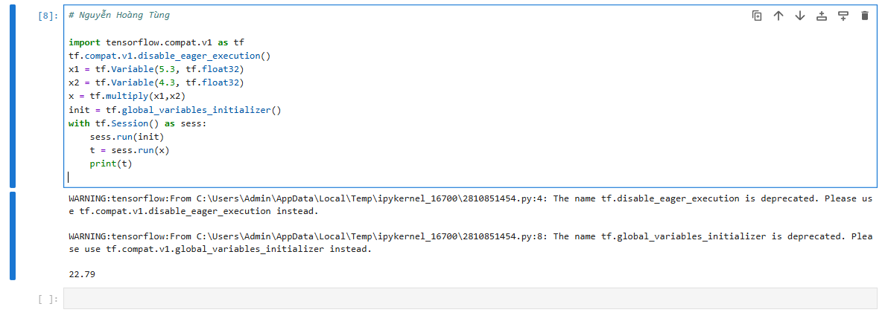
3.2.2.
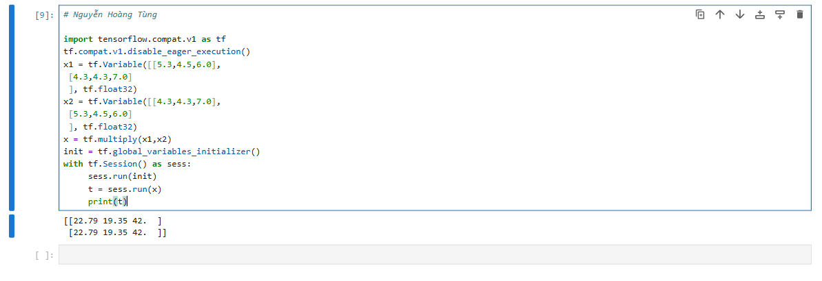
3.2.3.
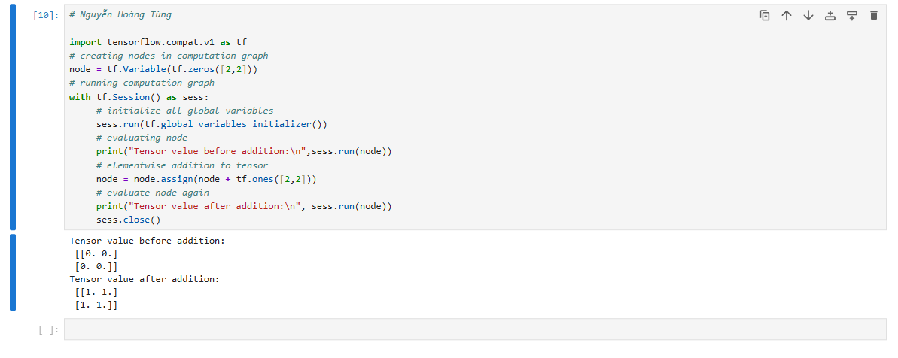
tf.Variable is a tensor that can change its value during program execution, is often used to store model parameters (e.g. weights, bias) during neural network training.

3.3.
3.3.1.
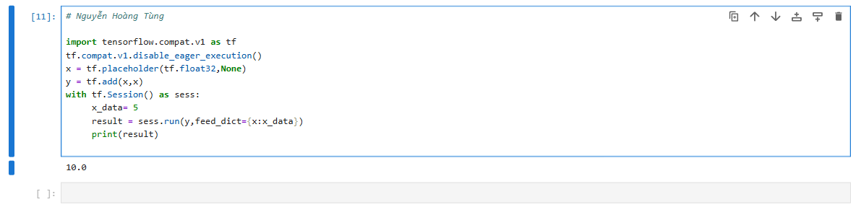
3.3.2.
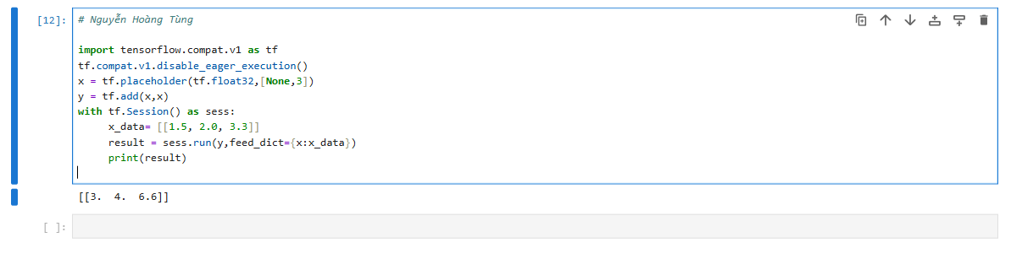
3.3.3.
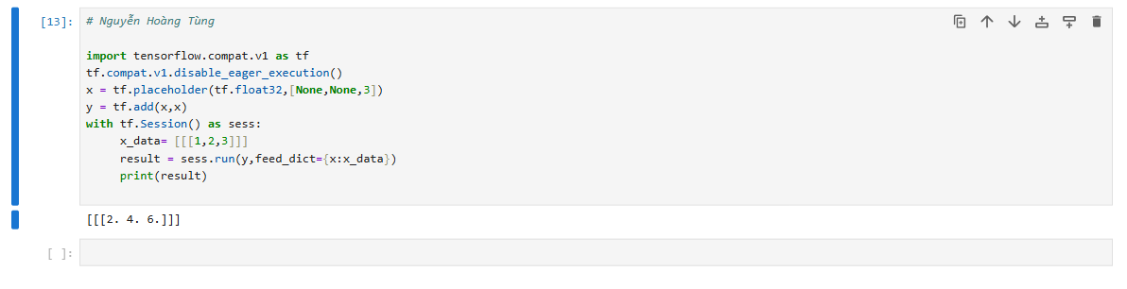
3.3.4.
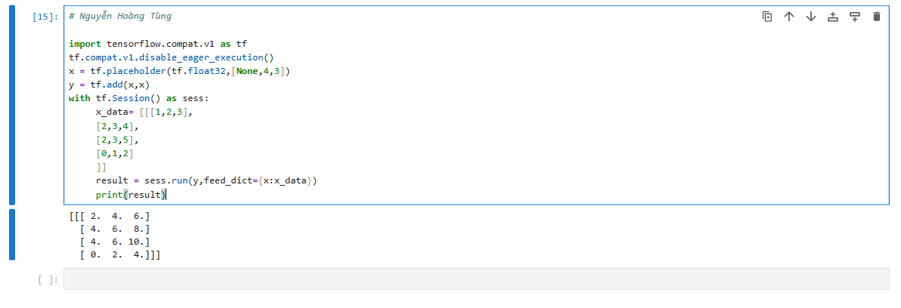
3.3.5.
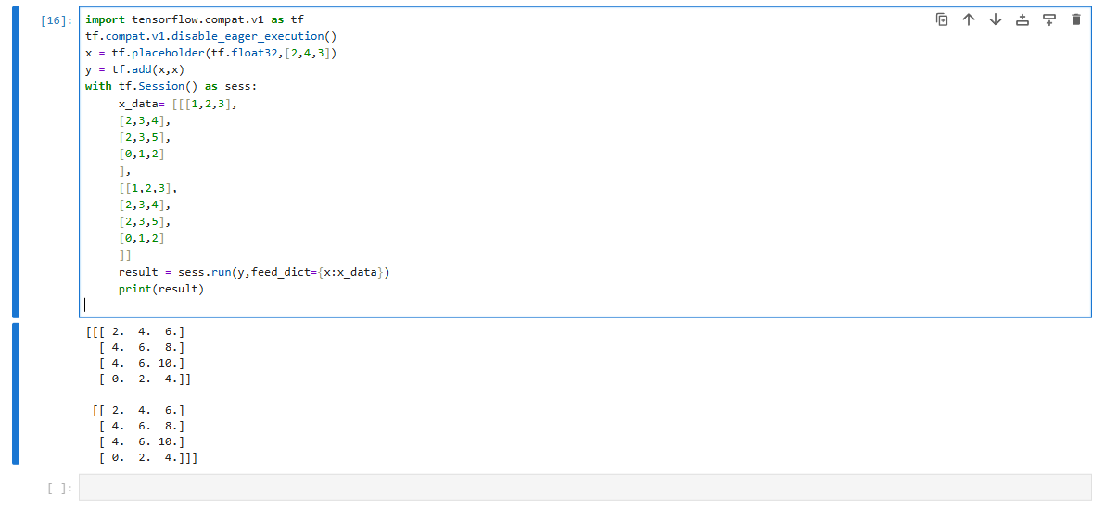
3.3.6.
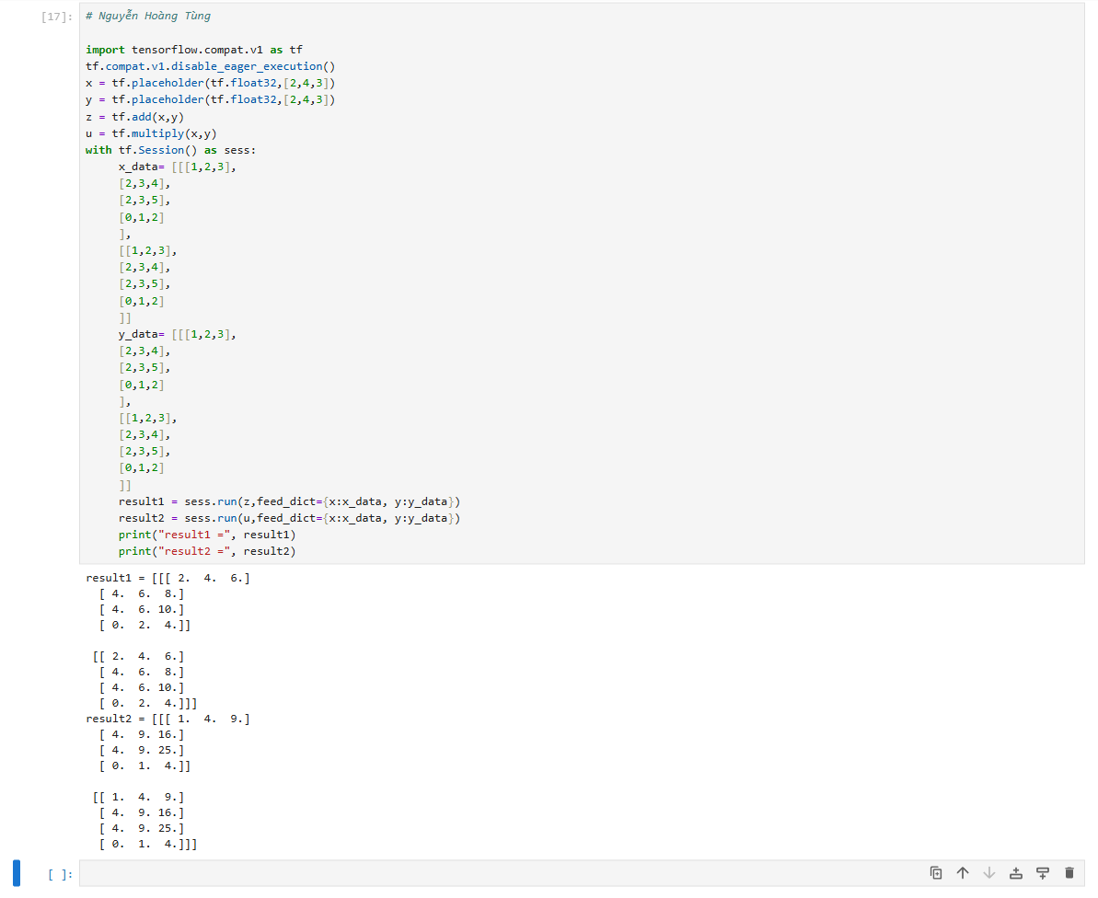
tf.placeholder(dtype, shape) is a placeholder for loading external data into the computation graph. The value of the placeholder will be provided when running the session using the Feed_dict parameter, often used to feed data trainers (inputs, labels) into the model. Placeholders do not contain available values, expected to be fed data at the time of the new run.

3.4.
3.4.1.
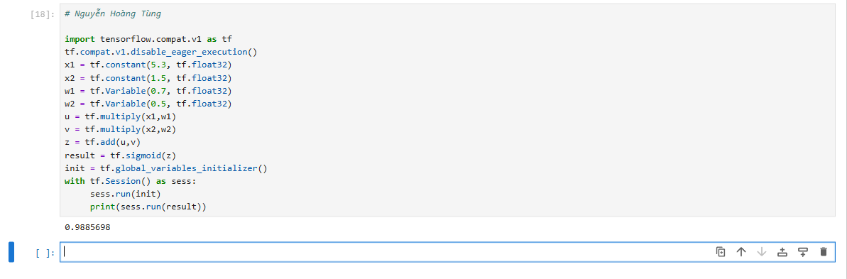
3.4.2.
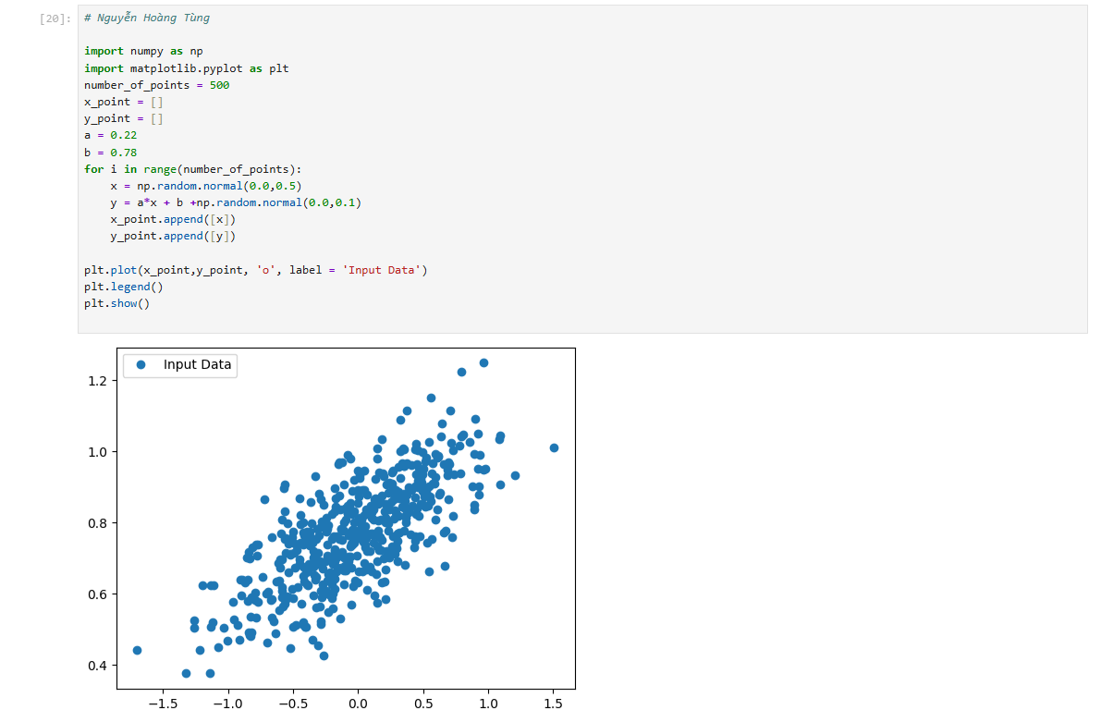
3.4.3.
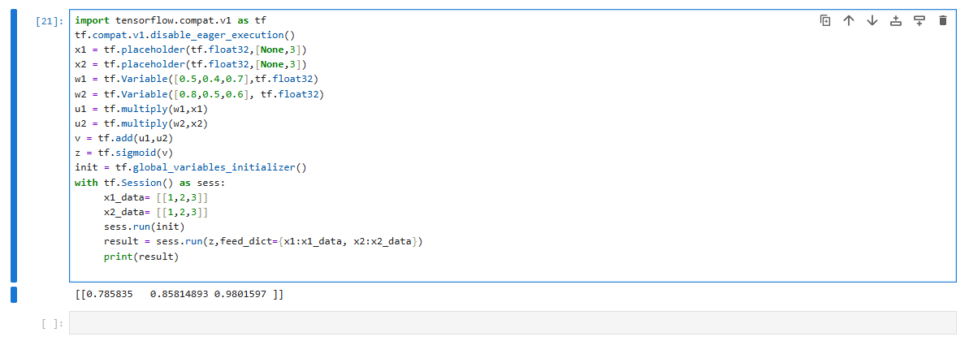
3.4.4.
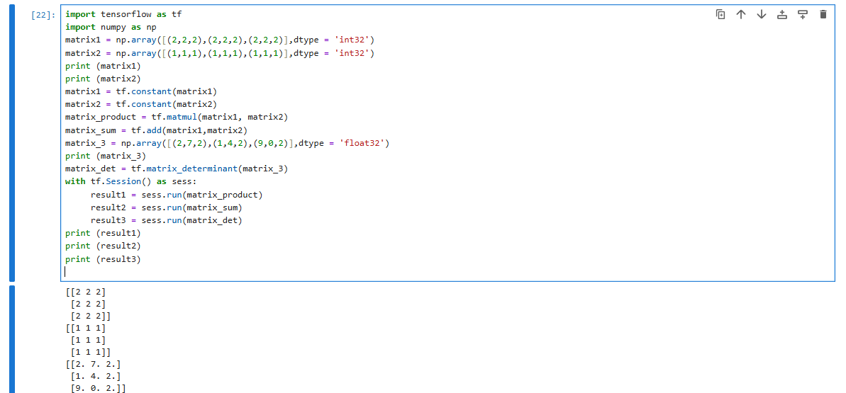
An operation (op) in TensorFlow is a node in a computational graph that represents a calculation (addition, multiplication, sigmoid, matrix, …). Constants, variables, and placeholders are data, and operations are actions that manipulate that data. To run an operation, you must call sess.run(op) or .eval() (in TF1.x).

3.5.
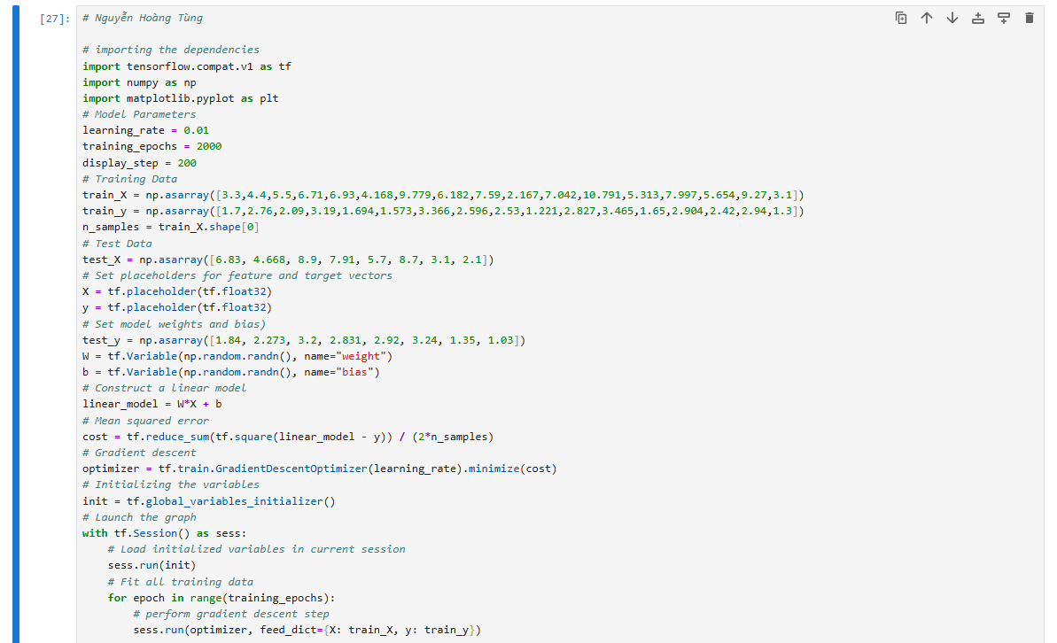
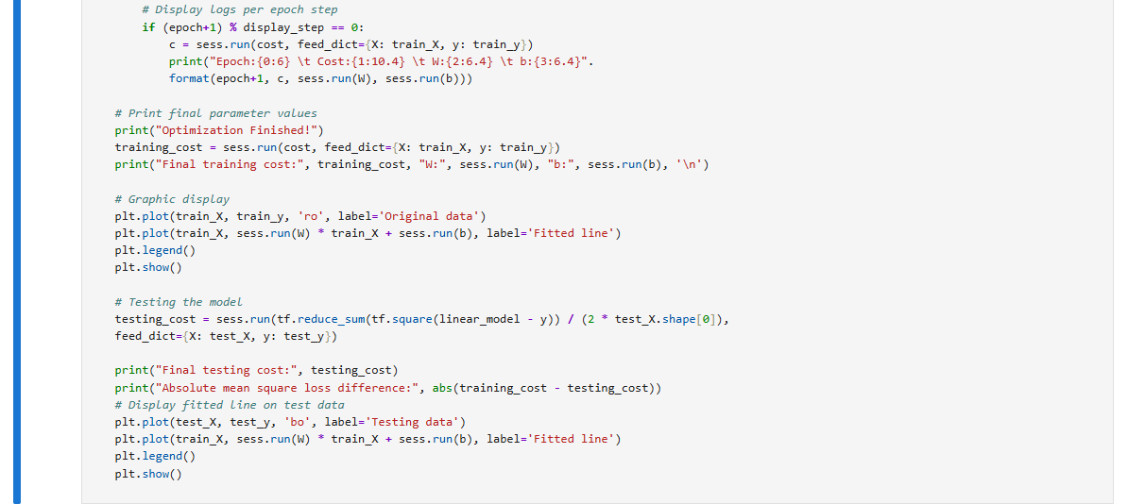
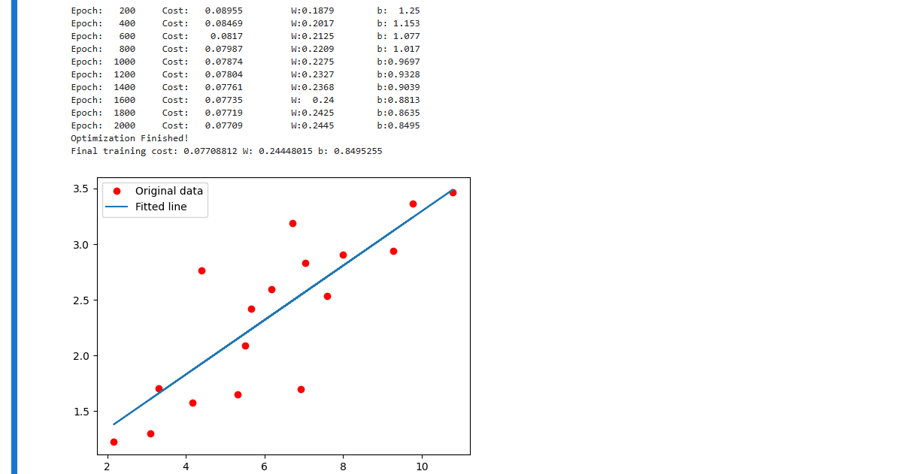
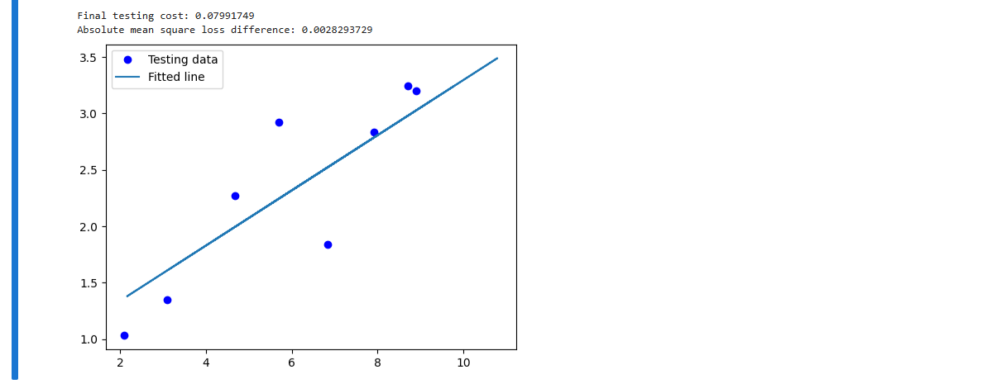
Explaination
Dependencies
1. import tensorflow.compat.v1 as tf
2. import numpy as np
3. import matplotlib.pyplot as plt
4. tf.compat.v1.disable_eager_execution()
5.
- Using TensorFlow 1.x style (Session, placeholder).
- numpy → for data handling.
- matplotlib → for plotting.

Hyperparameters
1. learning_rate = 0.01
2. training_epochs = 2000
3. display_step = 200
4.
- Learning rate: how big the gradient descent update steps are.
- Epochs: how many iterations we train.
- Display step: how often to print training progress.

Training & Test Data
1. train_X = np.asarray([...])
2. train_y = np.asarray([...])
3. n_samples = train_X.shape[0]
4.
5. test_X = np.asarray([...])
6. test_y = np.asarray([...])
7.
- Training data → used to learn the parameters W, b.
- Test data → used later to evaluate performance.

Placeholders (inputs/outputs)
1. X = tf.placeholder(tf.float32)
2. y = tf.placeholder(tf.float32)
3.
- X and y are placeholders → we will feed actual values during training using feed_dict.

Model Parameters
1. W = tf.Variable(np.random.randn(), name="weight")
2. b = tf.Variable(np.random.randn(), name="bias")
3.
- Trainable parameters that TensorFlow will optimize.
- Initialized randomly.

Model Definition
1. linear_model = W*X + b
2.
- Predicted value (ŷ) is a straight line.

Cost Function (Mean Squared Error)
1. cost = tf.reduce_sum(tf.square(linear_model - y)) / (2*n_samples)
2.
- Measures how far predictions are from actual values.
- Divided by 2*n_samples (classical linear regression formula).

Optimizer
1. optimizer = tf.train.GradientDescentOptimizer(learning_rate).minimize(cost)
2.
- Gradient Descent updates W and b to minimize the cost function.

Training Process
1. init = tf.global_variables_initializer()
2. with tf.Session() as sess:
3. sess.run(init)
4. for epoch in range(training_epochs):
5. sess.run(optimizer, feed_dict={X: train_X, y: train_y})
6.
- Initialize variables.
- Run training loop → optimizer adjusts W and b each step.

Logging Training Progress
1. if (epoch+1) % display_step == 0:
2. c = sess.run(cost, feed_dict={X: train_X, y: train_y})
3. print("Epoch:", epoch+1, "Cost:", c, "W:", sess.run(W), "b:", sess.run(b))
4.
- Every 200 epochs → print current cost, weight, and bias.
- Helps track learning progress.

Final Results & Visualization
1. print("Final training cost:", training_cost, "W:", sess.run(W), "b:", sess.run(b))
2.
3. plt.plot(train_X, train_y, 'ro', label='Original data')
4. plt.plot(train_X, sess.run(W) * train_X + sess.run(b), label='Fitted line')
5. plt.legend()
6. plt.show()
7.
- After training, display learned line vs training data.
- Red dots = original data, line = model’s prediction.

Testing the Model
1. testing_cost = sess.run(
2. tf.reduce_sum(tf.square(linear_model - y)) / (2 * test_X.shape[0]),
3. feed_dict={X: test_X, y: test_y})
4.
- Compute test cost (MSE) to see generalization.
- Compare training vs testing performance.

3.6.
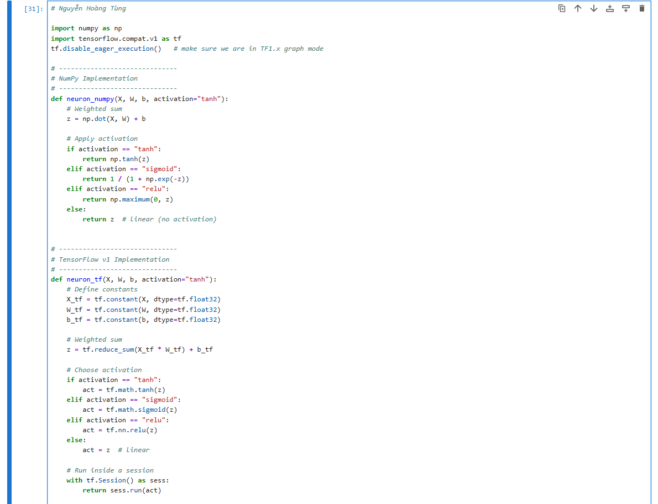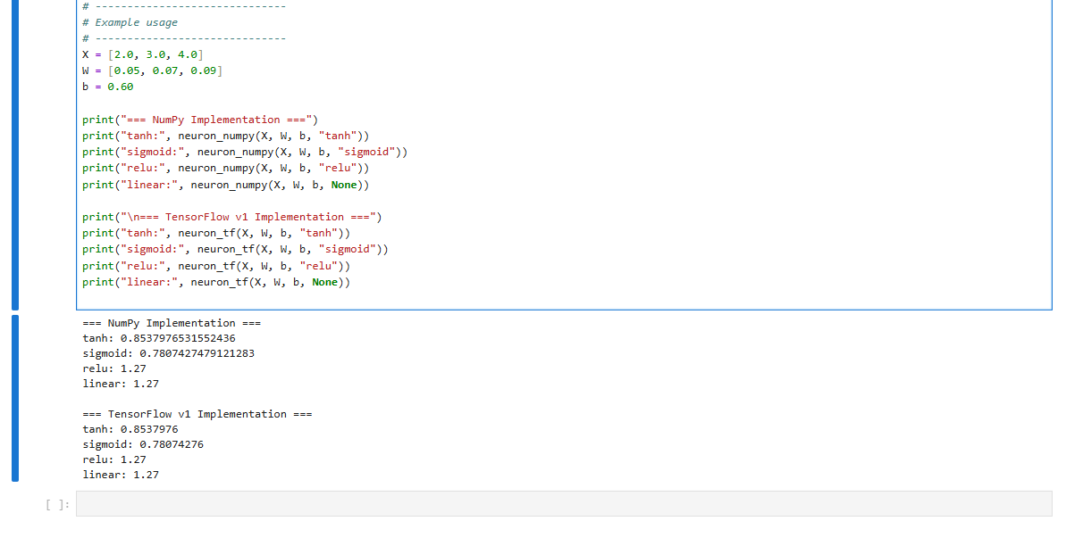
Explaination
- Weighted sum → Each input is multiplied by its corresponding weight, then all are summed with a bias.
- Activation function (tanh) → Introduces non-linearity into the model.
- Without it, the neuron would just compute a linear function.
- With tanh, the output is squeezed into the range [−1,1][-1, 1][−1,1].
- Output → The final transformed value (here ≈ 0.8538) is what flows to the next layer or becomes the prediction.

3.7.
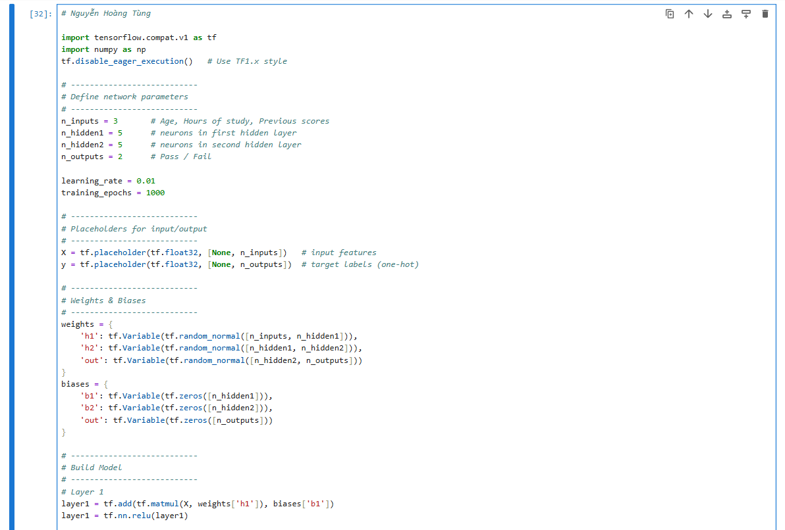
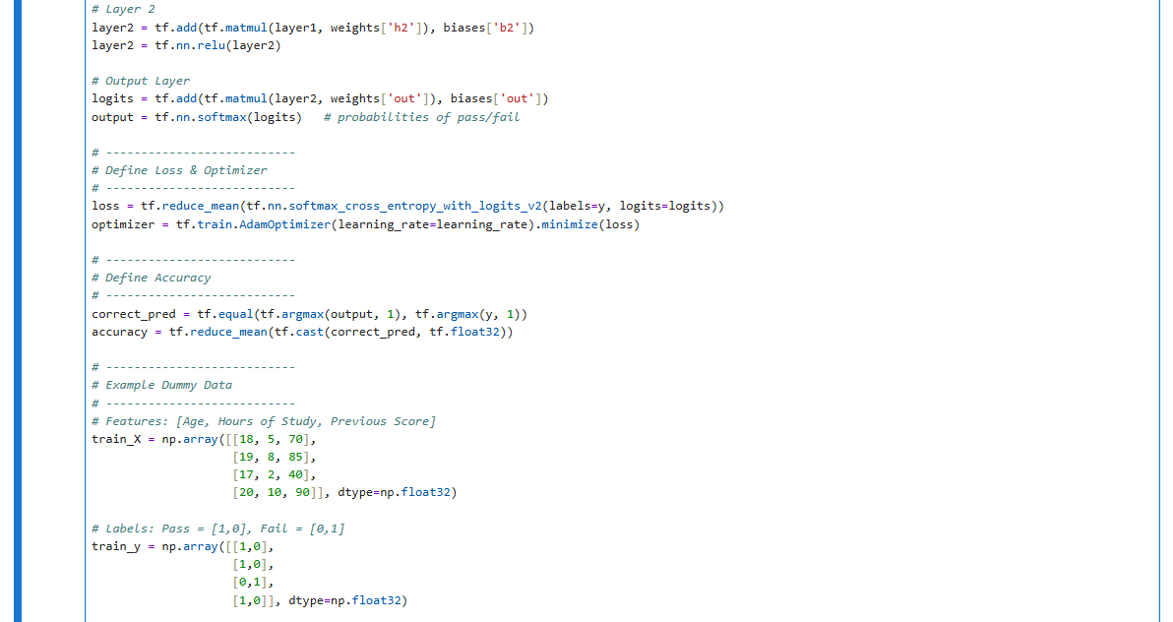
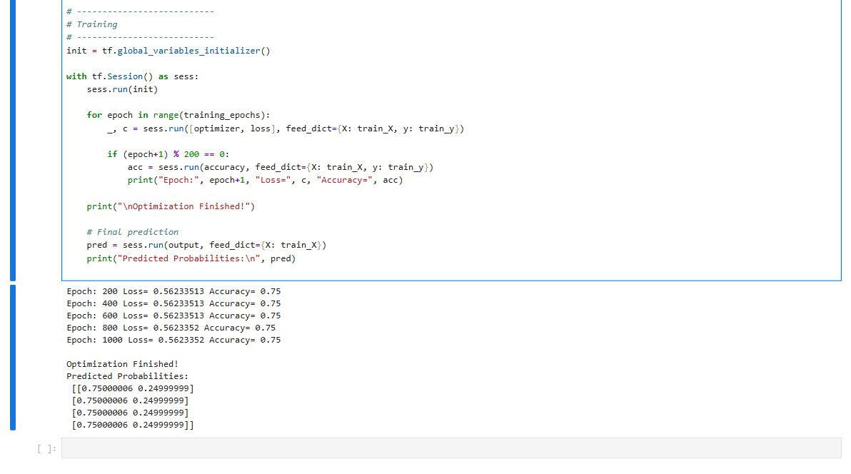
Explaination
- Input placeholders:
X stores input data (3 features).
y stores expected output (Pass/Fail, one-hot encoded).
- Weights & Biases:
Randomly initialized for each layer. These are trainable.
- Model Layers:
  - layer1 = ReLU(XW + b)
  - layer2 = ReLU(layer1W + b)
  - output = softmax(logits)
- Loss:
softmax_cross_entropy measures how well predictions match labels.
- Optimizer:
AdamOptimizer adjusts weights using gradient descent.
- Accuracy:
Compares predicted class vs true class.
- Training Loop:
Runs 1000 epochs. Every 200 steps, prints loss and accuracy.
- Prediction:
At the end, prints probability of Pass vs Fail for each input.

3.8.
1. Explanation of "model, layer, batch, epoch, structure, loss, optimization, gradient" with simple examples:
- Model A deep learning model is fundamentally a graph of layers that maps input data to predictions. In Keras, models are typically instances of the Model class, which can be simple Sequential stacks of layers or more complex multi-input, multi-output networks.
  - Example: For classifying handwritten digits (like in the MNIST dataset), a model might consist of a sequence of two Dense layers, where the final layer is a 10-way softmax classification layer to output probabilities for each digit (0-9). You can visualize a deep network as a multi-stage information-distillation process, where data passes through successive filters, becoming increasingly purified and informative for a specific task.
- Layer A layer is the central class of Keras and serves as a fundamental building block of a neural network. Each layer encapsulates certain weights (learnable parameters) and performs specific computations.
  - Example: A Dense layer (also called a fully connected layer) implements an affine transformation: output = relu(dot(input, W) + b), where W and b are the layer's weights, and relu is an activation function. The number of "units" in a Dense layer determines the dimensionality of the representation space it learns. Other examples include Conv2D layers for image processing and LSTM or GRU layers for sequence data.
- Batch Deep learning models do not process an entire dataset at once. Instead, they divide the data into small subsets called batches or mini-batches. These batches are typically between 8 and 128 samples in size, often a power of 2 to optimize GPU memory allocation.
  - Example: In the MNIST handwritten digit classification, a batch of 128 images would be processed simultaneously. During training, one batch is used to compute a single gradient-descent update to the model's weights.
- Epoch An epoch refers to one complete iteration over all samples in the training data. During training, a model is typically exposed to the entire training dataset for a specified number of epochs.
  - Example: Training the movie review classification model for "20 epochs" means the model will iterate through the entire training dataset 20 times, with each iteration consisting of multiple mini-batch updates.
- Structure The structure of a neural network refers to its architecture or topology, which is essentially how layers are organized and connected. This structure defines the "hypothesis space," or the predefined space of possibilities, within which the machine learning algorithm searches for useful data representations.
  - Example: A Sequential model in Keras represents a simple stack of layers. More complex structures include networks with residual connections, multi-head attention (like in the Transformer architecture), or multiple input/output branches. The choice of structure (e.g., Dense network for tabular data, convnet for images, RNN for timeseries) is crucial as it encodes assumptions about the data's inherent structure.
- Loss (function) The loss function (also known as the objective function or cost function) is a critical component that measures how well the network's output (predictions) aligns with the true target values. It quantifies the "distance" or mismatch between what the model predicted and what it was supposed to predict.
  - Example: For binary classification (e.g., classifying movie reviews as positive or negative), binary_crossentropy is a common loss function. For regression problems (e.g., predicting house prices), mean_squared_error (MSE) is widely used. The loss function's score acts as a feedback signal to guide the model's learning process. It must be differentiable for gradient descent to work.
- Optimization Optimization is the process by which a machine learning model updates its internal parameters (weights) to improve its performance by minimizing the loss function. This is typically achieved through gradient-based optimization algorithms.
  - Example: Stochastic Gradient Descent (SGD) is a fundamental optimization algorithm. Variants of SGD, known as optimizers, like RMSprop, Adam, or Adagrad, are used in practice. The optimizer dictates the exact way the gradient of the loss is used to adjust parameters.
- Gradient A gradient is essentially the derivative of a tensor operation. In the context of neural networks, it indicates the direction of the steepest increase of the loss function with respect to the model's weights.
  - Example: If you want to decrease the loss, you move the model's weights in the opposite direction of the gradient. The Backpropagation algorithm is the central mechanism in deep learning for efficiently computing these gradients across all layers of a neural network. Modern frameworks like TensorFlow provide tools like GradientTape for automatic differentiation, so practitioners don't have to manually compute gradients.

2. Explanation of Figures 2.21, 2.22, 2.23, 2.24, 2.25:
These figures visually explain the concept of computation graphs and the Backpropagation algorithm, which is fundamental to how neural networks learn.
- Figure 2.21: The computation graph representation of our two-layer model This figure depicts a directed acyclic graph (DAG), which is the underlying data structure in TensorFlow for representing computations. It illustrates a two-layer neural network model, showing how various inputs (e.g., x for input data, W1, b1, W2, b2 for weights, and y_true for true targets) flow through a series of tensor operations (e.g., dot product, relu activation, + addition, softmax activation, and loss function) to produce a final loss_val. This graph allows for the treatment of computation as data, which is crucial for features like automatic differentiation and distributed computing.
- Figure 2.22: A basic example of a computation graph This is a simplified version of a computation graph, used to make the explanation of backpropagation clearer by using scalar variables instead of tensors. It shows inputs (x, b, w, y_true) passing through elementary operations (*, +, loss) to produce intermediate results (x1, x2) and ultimately a loss_val. The goal in this context is to compute the gradients of loss_val with respect to the learnable parameters w and b to minimize the loss.
- Figure 2.23: Running a forward pass This figure demonstrates the "forward pass" on the simplified computation graph from Figure 2.22. It shows numerical values being propagated through the graph from the inputs to the output. For example, if x=2 and w=3, then x1 becomes 2*3 = 6. If x1=6 and b=1, then x2 becomes 6+1 = 7. Finally, if y_true=4 and x2=7, the loss_val is abs(4-7) = 3. The forward pass is the process of computing the model's predictions and loss for a given input.
- Figure 2.24: Running a backward pass This figure introduces the concept of the "backward pass" as part of backpropagation. It shows the computation graph from Figure 2.23 "reversed," with each edge annotated by a local derivative, grad(B, A), which represents how much B varies when A varies. For instance, grad(loss_val, x2) = 1 indicates that the change in loss_val is directly proportional to the change in x2 in this specific example. This process begins at the loss_val and works backward through the graph to compute derivatives for all intermediate nodes and input parameters.
- Figure 2.25: Path from loss_val to w in the backward graph This figure specifically illustrates how the chain rule is applied within the backward pass. It highlights the path from loss_val back to the parameter w. According to the chain rule, the gradient of loss_val with respect to w (grad(loss_val, w)) is found by multiplying the derivatives along this path: grad(loss_val, x2) * grad(x2, x1) * grad(x1, w). In this example, 1 * 1 * 2 results in grad(loss_val, w) = 2. This multiplication of local derivatives is the core of backpropagation, allowing efficient computation of how each parameter contributes to the final loss.

3. Understanding of section 3.6: "Anatomy of a neural network: Understanding core Keras APIs"
Section 3.6 serves as a foundational guide to understanding the structure and operational aspects of neural networks within the Keras framework, a high-level API for TensorFlow. My understanding of this section is as follows:
The section establishes that a deep learning model is essentially a graph of interconnected layers, with the Model class (and its subclass Sequential) being central to Keras for building these structures. While Sequential models are straightforward stacks of layers, the more flexible Functional API (and Model subclassing) allows for complex network structures like multi-input/output systems or residual connections. The choice of network topology is crucial as it defines the "hypothesis space"—the set of possible functions the model can learn.
A key part of the workflow is the compile() step, where the learning process is configured before training. This involves selecting three vital components:
- Loss function: This is the objective that the model will minimize during training, acting as a measure of success for the given task. For example, binary_crossentropy for binary classification, categorical_crossentropy for multiclass classification, and mean_squared_error for regression. The importance of choosing a loss function that accurately reflects the problem's goal is heavily emphasized, warning that a poorly chosen one can lead to unintended "shortcuts" by the model.
- Optimizer: This dictates how the model's weights are updated based on the gradient of the loss function, implementing a variant of stochastic gradient descent. rmsprop is presented as a generally good default choice.
- Metrics: These are measures used to monitor the model's performance during training and validation, such as "accuracy". Unlike the loss function, metrics do not need to be differentiable as they are not directly optimized.
The section then underscores the critical role of validation data. It explains that a model's performance must be monitored on data it has never seen during training (the validation set) to assess its generalization ability and to detect overfitting, where the model performs well on training data but poorly on new data. This monitoring is done by passing validation_data to the fit() method.
Finally, the section briefly covers inference, which is the process of using a trained model (via methods like predict()) to generate outputs for new, unseen inputs in a practical setting.
In summary, section 3.6 provides a comprehensive "anatomical" and "instructional" view of how to construct, configure, and evaluate Keras-based neural networks, covering the roles of layers, models, loss functions, optimizers, and the crucial practice of validating performance for generalization. It equips the reader with the core Keras APIs necessary for practical deep learning applications.

3.9.
1. Processing MNIST with Keras
Explanation of the Keras Approach:
The Keras workflow typically involves four main steps:
- Loading and Preparing Data: Keras preloads common datasets like MNIST, which can then be easily reshaped and normalized.
- Defining the Model Architecture: A model is built as a graph of layers, with Sequential models being simple stacks of layers. Each layer (Dense, Conv2D, etc.) encapsulates weights and performs specific computations.
- Compiling the Model: This step configures the learning process by specifying the optimizer (how weights are updated), loss function (what to minimize), and metrics (what to monitor).
- Training and Evaluating the Model: The fit() method runs the training loop, processing data in batches over several epochs, and evaluate() assesses performance on new data.
Keras Code for MNIST Classification:
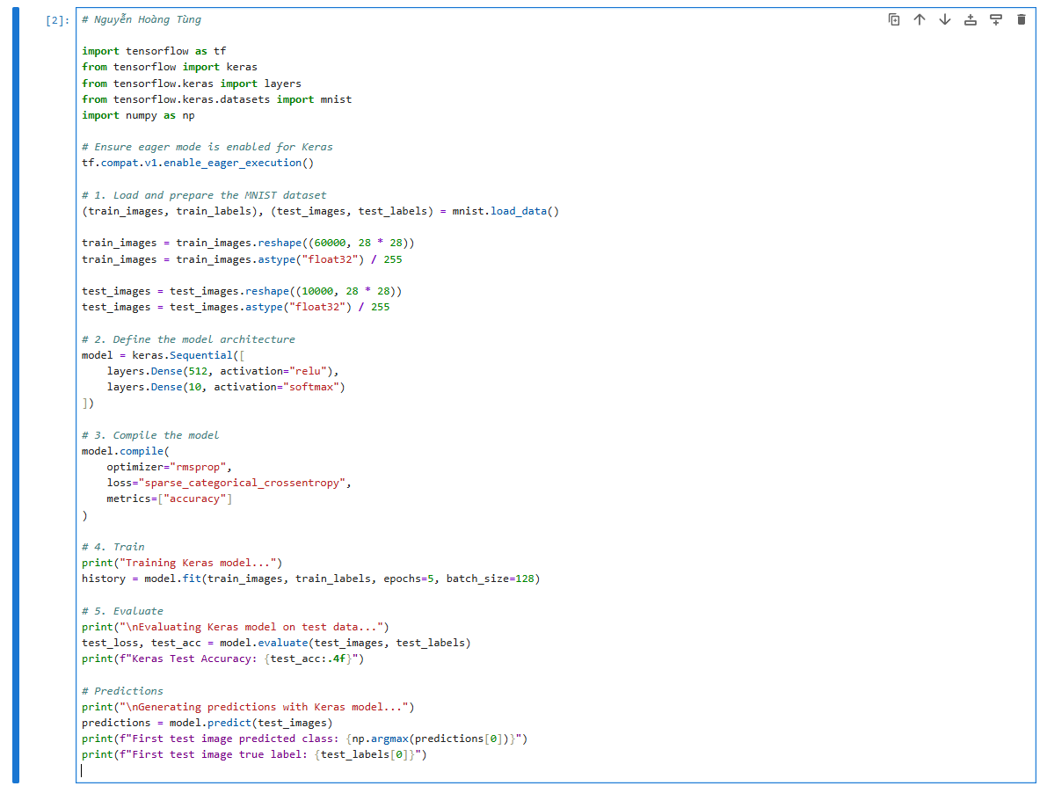
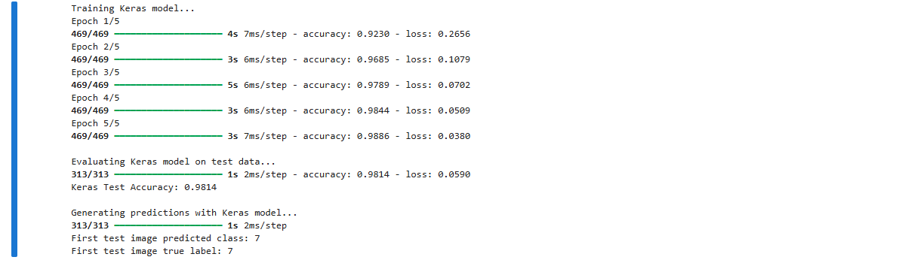
Explanation of the Keras Code:
- mnist.load_data(): Downloads and loads the MNIST dataset, returning training and test images/labels as NumPy arrays.
- reshape() and astype("float32") / 255: Transforms each 28x28 image into a 784-element vector and normalizes pixel values from to for better network performance.
- keras.Sequential([...]): Creates a model by stacking layers sequentially.
- layers.Dense(units, activation="relu"): Adds a densely connected layer. The relu activation introduces non-linearity, allowing the model to learn complex transformations.
- layers.Dense(10, activation="softmax"): The final layer outputs 10 probabilities, one for each digit class. softmax ensures these probabilities sum to 1.
- model.compile(...): Configures the training process. rmsprop is a common optimizer, sparse_categorical_crossentropy is a suitable loss for integer labels in multiclass classification, and accuracy is a metric to track.
- model.fit(...): Trains the model. epochs specifies how many times the entire training dataset is passed through the network, and batch_size determines the number of samples per gradient update.
- model.evaluate(...): Calculates the loss and metrics (e.g., accuracy) on the test data to assess generalization performance.
- model.predict(...): Generates probability predictions for new input data.

2. Processing MNIST WITHOUT Keras (Pure TensorFlow)
Explanation of the Pure TensorFlow Approach:
Building a neural network without Keras's high-level Sequential and fit() involves:
- Manual Layer and Model Definition: Instead of keras.layers.Dense, you define a custom Dense layer class that holds tf.Variable instances for weights and biases, and implements the forward pass. A Sequential model class is also defined to chain these custom layers.
- Data Handling: A BatchGenerator is implemented to manually iterate over the dataset in mini-batches.
- Loss and Optimizer: Loss functions (like sparse_categorical_crossentropy) and optimizers (like RMSprop) are used directly from tf.keras.losses and tf.keras.optimizers, as they are core TensorFlow components.
- Custom Training Loop: This is the core difference. Instead of model.fit(), a manual loop iterates through epochs and batches. For each batch:
  - Forward Pass: Input data flows through the custom layers to produce predictions.
  - Loss Computation: The predictions are compared to true labels using a chosen loss function.
  - Backward Pass (Gradient Calculation): tf.GradientTape records operations to automatically compute gradients of the loss with respect to all tf.Variables (weights and biases).
  - Weight Update: The optimizer uses these gradients to update the model's weights in the direction that minimizes the loss.
- Evaluation Loop: Similar to training, a manual loop processes test data in batches to calculate overall loss and accuracy.
Pure TensorFlow Code for MNIST Classification:
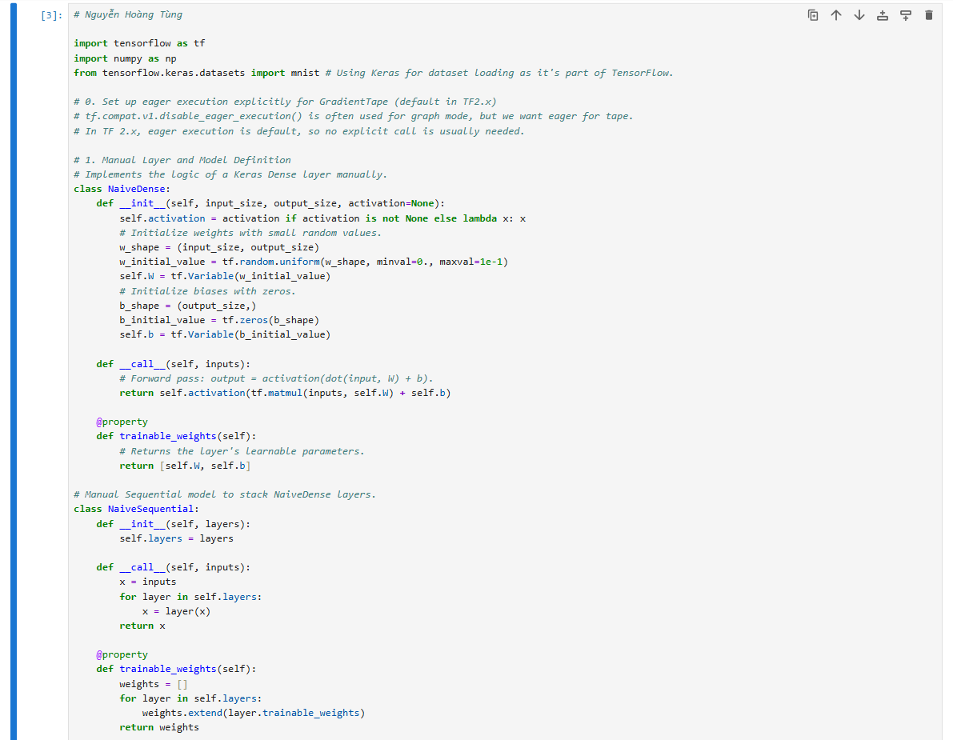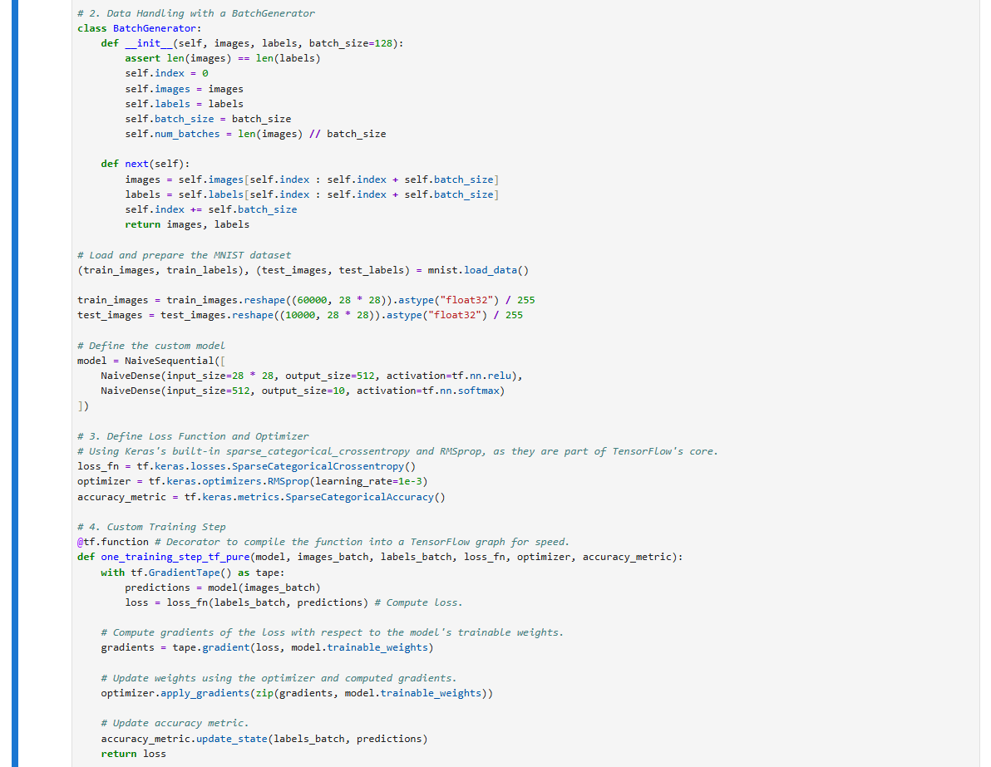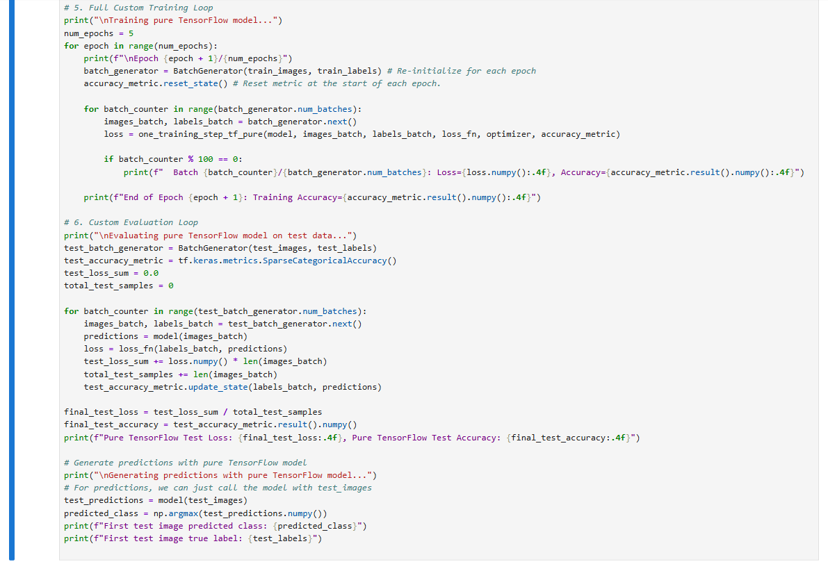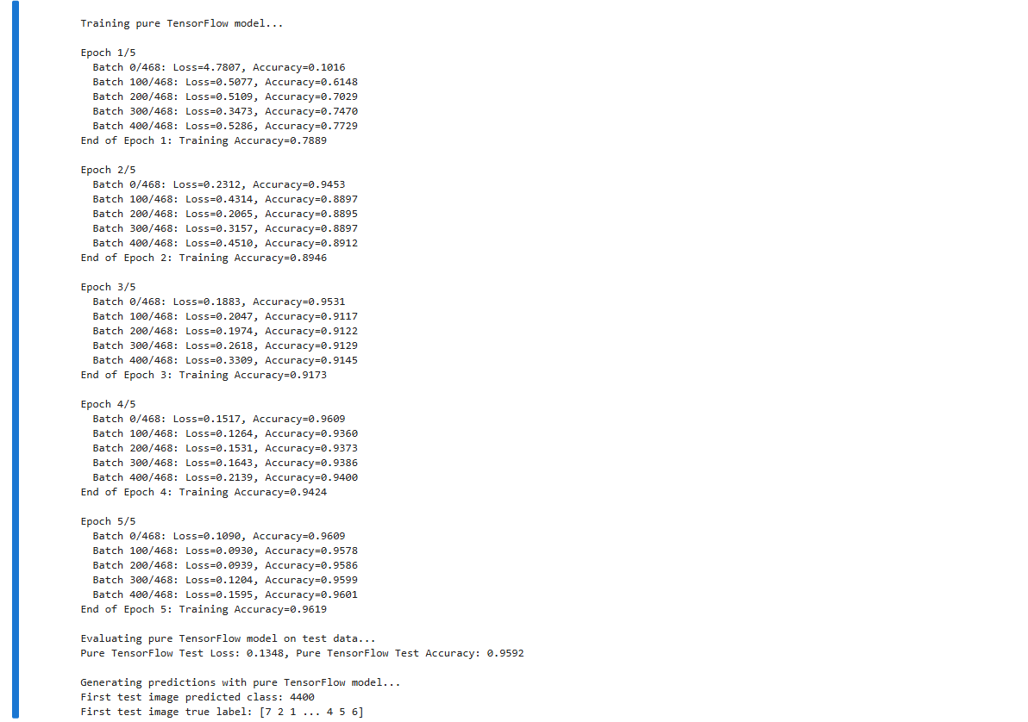
Explanation of the Pure TensorFlow Code:
- NaiveDense and NaiveSequential classes: These replace tf.keras.layers.Dense and tf.keras.Sequential. They manually define tf.Variable objects for weights (W) and biases (b), and implement the forward pass logic. The trainable_weights property is crucial for tf.GradientTape to identify parameters to optimize.
- BatchGenerator class: This utility manually handles splitting the dataset into mini-batches for iteration during training and evaluation.
- tf.keras.losses.SparseCategoricalCrossentropy() and tf.keras.optimizers.RMSprop(): Although they have "keras" in their path, these are fundamental TensorFlow components for loss calculation and gradient-based optimization.
- tf.keras.metrics.SparseCategoricalAccuracy(): Used to track accuracy, resetting its state at the beginning of each epoch or evaluation cycle.
- one_training_step_tf_pure function: This function encapsulates the core training logic for a single batch.
  - with tf.GradientTape() as tape:: This context manager records all operations performed within it to compute gradients later.
  - predictions = model(images_batch): Performs the forward pass using our custom NaiveSequential model.
  - loss = loss_fn(labels_batch, predictions): Calculates the loss between the model's predictions and the true labels.
  - gradients = tape.gradient(loss, model.trainable_weights): The GradientTape computes the gradient of the loss with respect to all tf.Variables in model.trainable_weights.
  - optimizer.apply_gradients(zip(gradients, model.trainable_weights)): Applies the calculated gradients to update the model's weights, moving them in the direction that reduces the loss.
- @tf.function: This decorator compiles the Python function into a static TensorFlow graph, significantly speeding up execution, especially for repetitive operations in training loops.
- Manual Training Loop: Iterates through epochs and, for each epoch, creates a BatchGenerator to process data in batches. It calls one_training_step_tf_pure for each batch and prints progress.
- Manual Evaluation Loop: Similar to the training loop, it iterates through test data batches, calculates loss and updates accuracy metric without applying gradients. This gives an unbiased measure of the model's generalization performance.
- model(test_images) for prediction: After training, the model can be directly called with new inputs to generate predictions.

3.10.
1. Key Concepts from Chapter 4:
- Machine Learning Tasks:
  - Binary Classification: Categorizing input samples into two exclusive classes, such as classifying movie reviews as positive or negative.
  - Multiclass Classification: Categorizing input samples into more than two exclusive classes, like classifying newswires into multiple topics or handwritten digits (like MNIST).
  - Scalar Regression: Predicting a continuous scalar value, such as estimating house prices. Vector regression for multiple continuous values is also mentioned.
- Data Preprocessing: Neural networks require data to be formatted into appropriately preprocessed floating-point tensors.
  - Vectorization: Converting raw data (like text) into numerical tensors. For text, this often involves multi-hot encoding (representing words as binary vectors) or using integer sequences with embedding layers.
  - Normalization: Scaling features in input data, especially when they have different ranges, to ensure they all take small values on a similar scale (e.g., dividing by 255 for image pixels, or standardizing features to have mean 0 and standard deviation 1 for numerical data).
- Model Architecture Principles:
  - Dense Layers: Often used as the core building blocks, implementing output = relu(dot(input, W) + b). The number of units (dimensionality of representation space) in these layers is a key architectural decision.
  - Output Layer and Activation Functions: The choice depends on the task.
    - Binary Classification: A single Dense unit with sigmoid activation, outputting a probability between 0 and 1.
    - Multiclass Classification (single-label): A Dense layer with units equal to the number of classes and a softmax activation, outputting a probability distribution over the classes.
    - Scalar/Vector Regression: A Dense layer with units equal to the number of values to predict and no activation function.
- Loss Functions: The quantity minimized during training, representing how well the model's predictions match the targets.
  - Binary Classification: binary_crossentropy.
  - Multiclass Classification: categorical_crossentropy (for one-hot encoded labels) or sparse_categorical_crossentropy (for integer labels).
  - Regression: mean_squared_error (MSE) or mean_absolute_error (MAE).
- Optimizers: Determines how the network's weights are updated based on the loss function, typically a variant of stochastic gradient descent (SGD). rmsprop is generally a good default choice.
- Model Evaluation:
  - Validation Sets: A subset of data held apart from training to monitor model accuracy and loss on new, unseen data during training, crucial for detecting overfitting.
  - Overfitting: The phenomenon where a model performs worse on new data than on its training data, indicating it has memorized training patterns rather than generalizing.
  - K-fold Cross-Validation: A technique used when little data is available to reliably evaluate a model, by splitting data into K partitions and training K models.
- Common-Sense Baselines: Essential for determining if a machine learning model is making real progress, by comparing its performance to a trivial non-machine learning approach.
Chapter 4 emphasizes the end-to-end machine learning workflow, from data preprocessing and model architecture design to evaluation, and the crucial importance of monitoring performance on data outside the training set to prevent overfitting.

2. Running code with datasets MNIST and IMDB
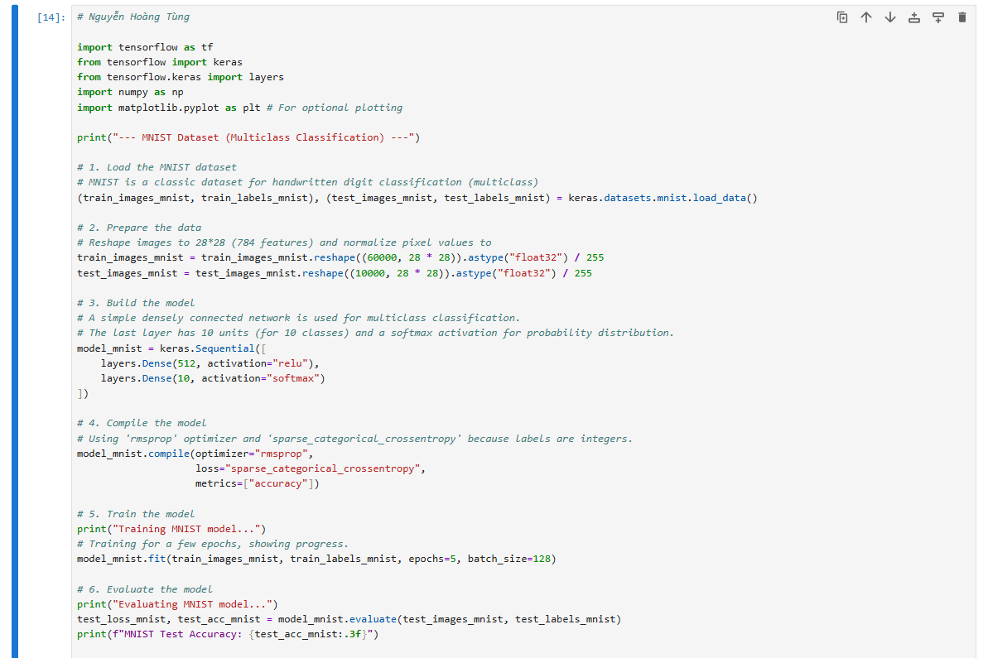
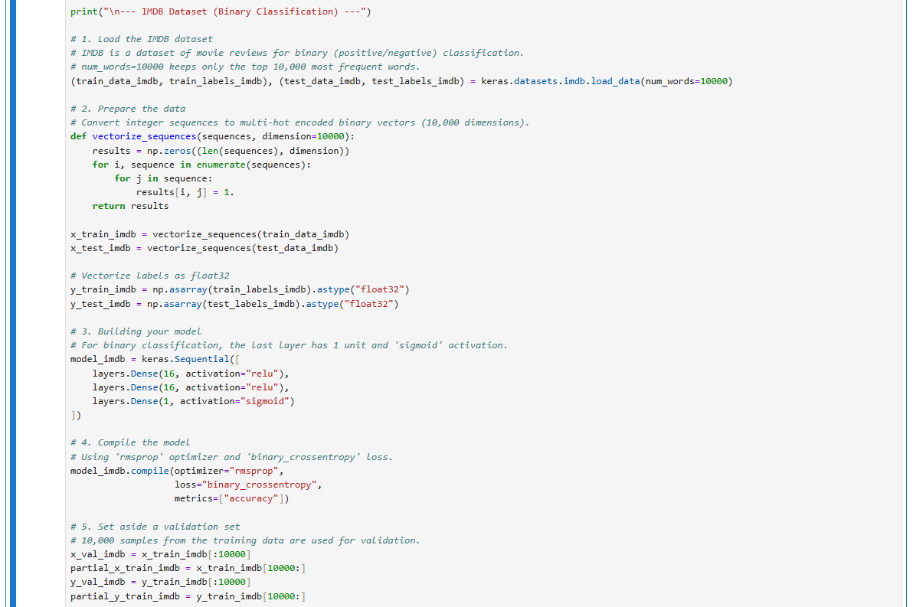
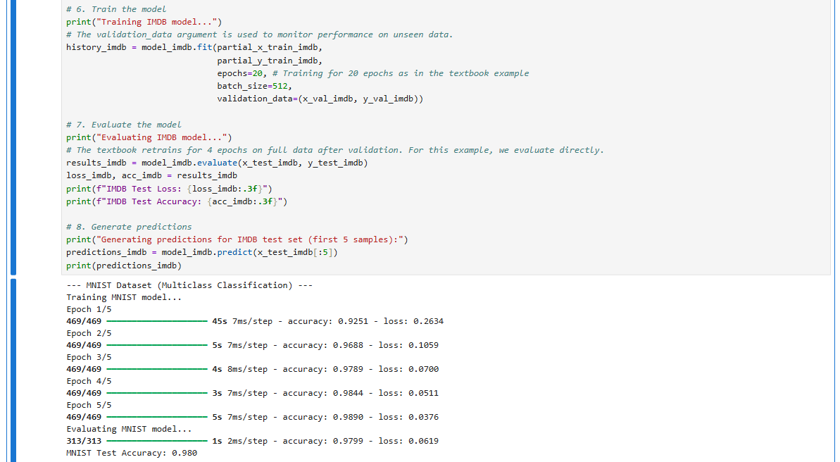
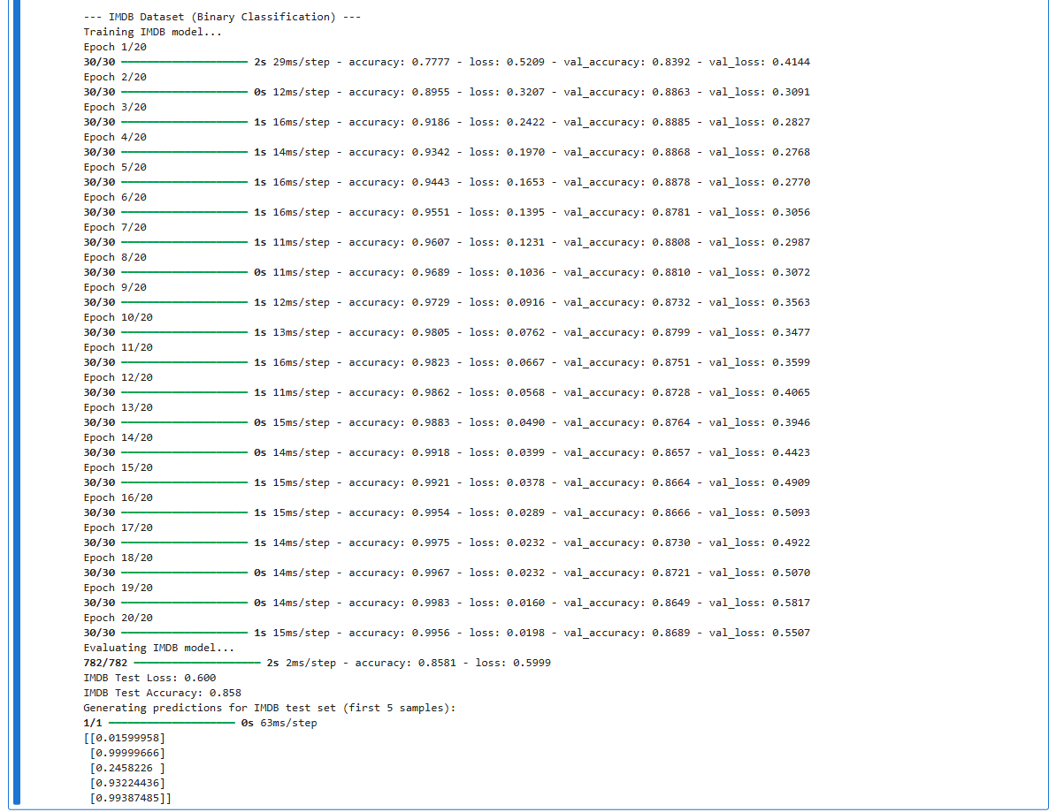

Explanation of the Code:
MNIST Dataset (Multiclass Classification):
- Loading Data: The mnist.load_data() function directly loads the dataset, which consists of 60,000 training images and 10,000 test images of handwritten digits (0-9). This is a multiclass classification problem.
- Data Preparation: The images, initially 28x28 pixel arrays, are reshaped into 784-dimensional vectors. Pixel values (0-255) are converted to float32 and normalized to the range by dividing by 255. This is a standard data preprocessing step for numerical stability.
- Model Building: A keras.Sequential model is built with two Dense layers. The first layer has 512 units and uses a relu activation function. The final Dense layer has 10 units (one for each digit class) and a softmax activation, which outputs a probability distribution over the 10 classes.
- Model Compilation: The model is configured for training using the compile() method. The rmsprop optimizer is chosen, which is a generally effective choice. The loss function is sparse_categorical_crossentropy, appropriate for multiclass classification when labels are integers. accuracy is specified as a metric to monitor performance.
- Model Training: The fit() method trains the model on the train_images_mnist and train_labels_mnist for 5 epochs. Each epoch iterates over the data in batches of 128 samples.
- Model Evaluation: The evaluate() method calculates the loss and accuracy on the test_images_mnist and test_labels_mnist, providing a final measure of the model's performance on unseen data.
IMDB Dataset (Binary Classification):
- Loading Data: The imdb.load_data() function loads 50,000 movie reviews, preprocessed into sequences of integers, where each integer represents a word. num_words=10000 limits the vocabulary to the 10,000 most frequent words. This is a binary classification problem (positive/negative sentiment).
- Data Preparation: The integer sequences representing reviews are converted into multi-hot encoded binary vectors of 10,000 dimensions. Each vector is mostly zeros, with ones at the indices corresponding to words present in the review. Labels (0s and 1s) are also cast to float32.
- Model Building: A keras.Sequential model is constructed with three Dense layers. The first two intermediate layers use relu activation with 16 units. The final Dense layer has 1 unit and a sigmoid activation, which outputs a probability of the review being positive (0-1), suitable for binary classification.
- Model Compilation: The model uses the rmsprop optimizer and binary_crossentropy as the loss function, which is standard for binary classification problems where the output is a probability. accuracy is again used as a metric.
- Validation Set: A subset of 10,000 samples from the x_train_imdb and y_train_imdb is set aside as a validation set (x_val_imdb, y_val_imdb). This is a crucial step to monitor the model's performance on data it hasn't seen during training, helping to identify and prevent overfitting.
- Model Training: The fit() method trains the model on the partial_x_train_imdb and partial_y_train_imdb. The validation_data argument points to the validation set, allowing Keras to compute and display validation loss and accuracy at the end of each epoch. This allows practitioners to observe the model's generalization performance during training.
- Model Evaluation: After training, the evaluate() method assesses the model's performance on the completely unseen x_test_imdb and y_test_imdb.
- Generating Predictions: Finally, the predict() method is used to generate likelihood scores (probabilities) for the first 5 samples of the test set, demonstrating how the trained model can be used for inference on new data.

